How to write a value to a Modbus device in PecStar
- Start PecConfig
- Add a site, select the Driver Type “MODBUS Protocol Master Site Driver”.
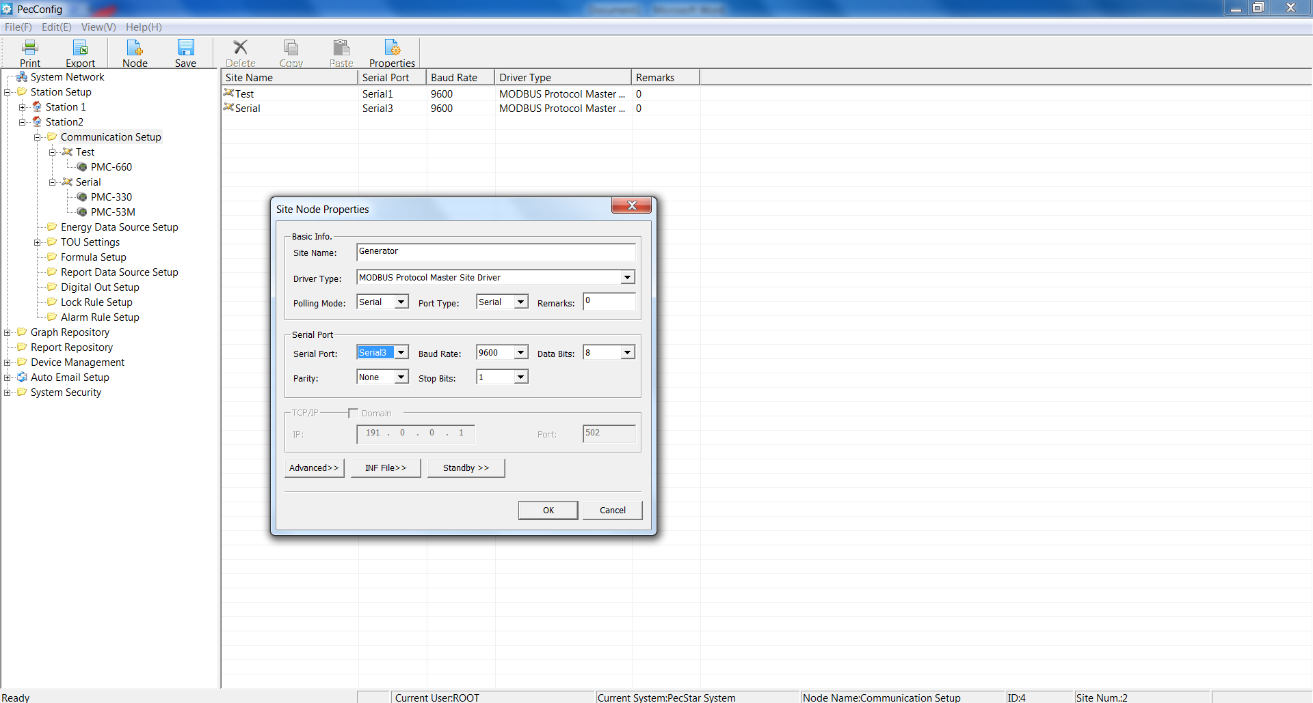
- Add a device, select the Device Type “ModbusMeter”.
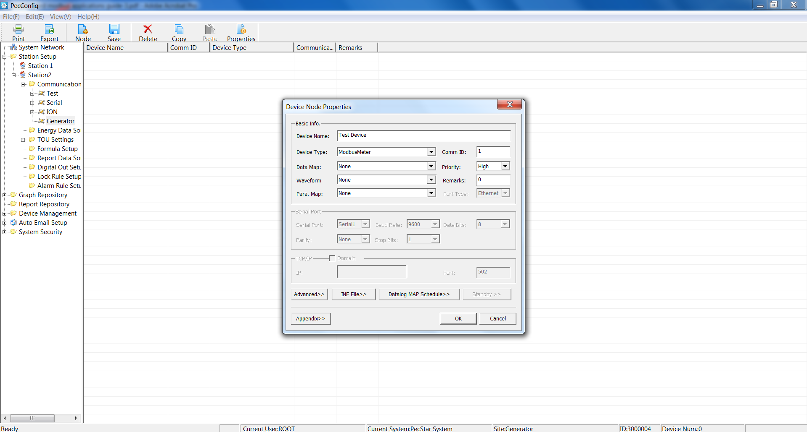
- Click Appendix>> on the Device Node Properties window, the following window appears.
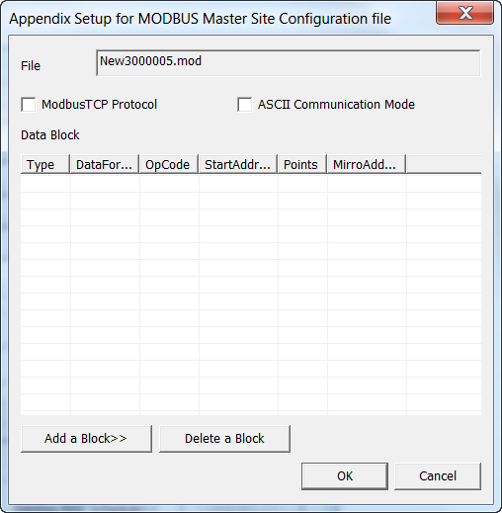
- Click Add a Block>>, setup the Modbus Block in the pop-up window. For example, to write to the register 302, enter the settings as below:
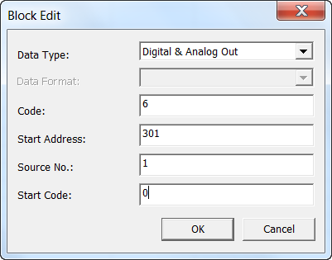
Click OK.
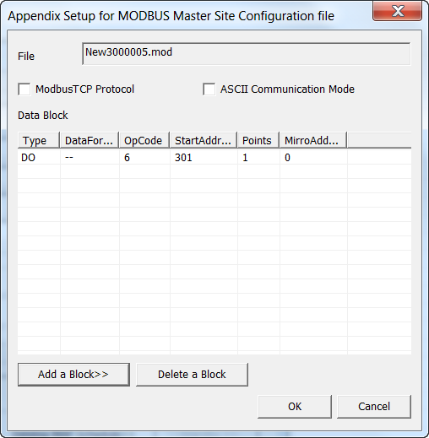
- Right-click on Digital Out Setup and select New…. The Digital Out Properties window appears. Enter the settings as below:
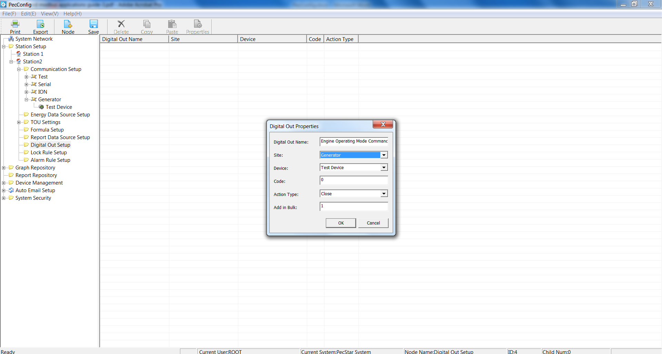
The Code in this window must be the same as the Start Code in step 4).
- The defined Digital Out is listed in the right-pane.
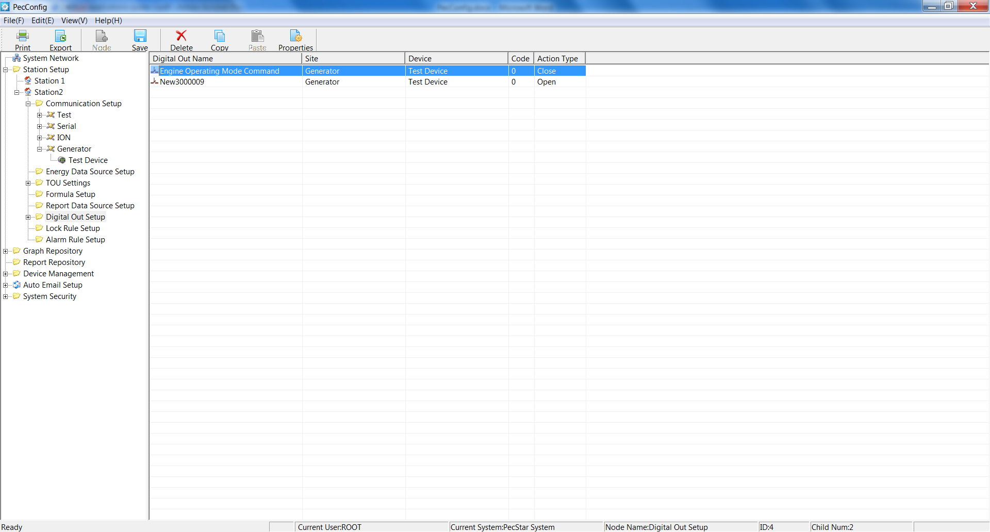
- Save the configuration to database.

- Start DServer.

- Start PecSCADA.

The Digital Out Sources are shown as below.
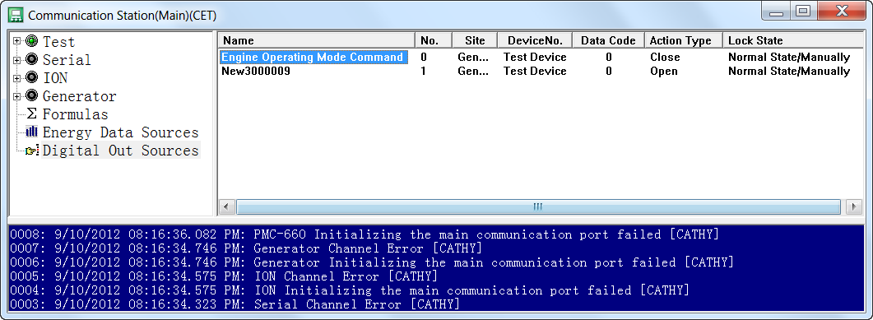
- Start PecDraw.
- Click New… to create a new Common Graph File.
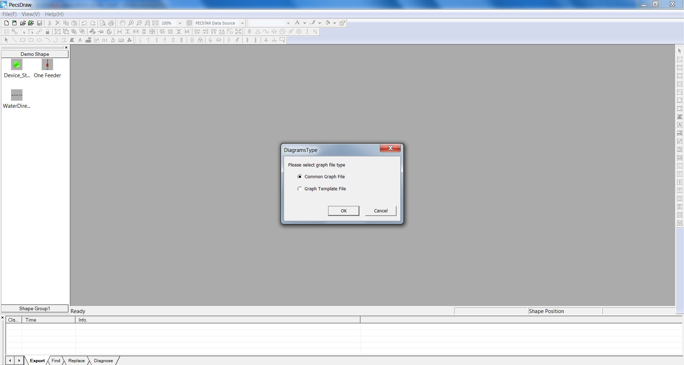
- Draw a Button. In the Properties windows, click the Mouse Left Click tab, select Remote Regulating, the Analog Out List dialog box appears.
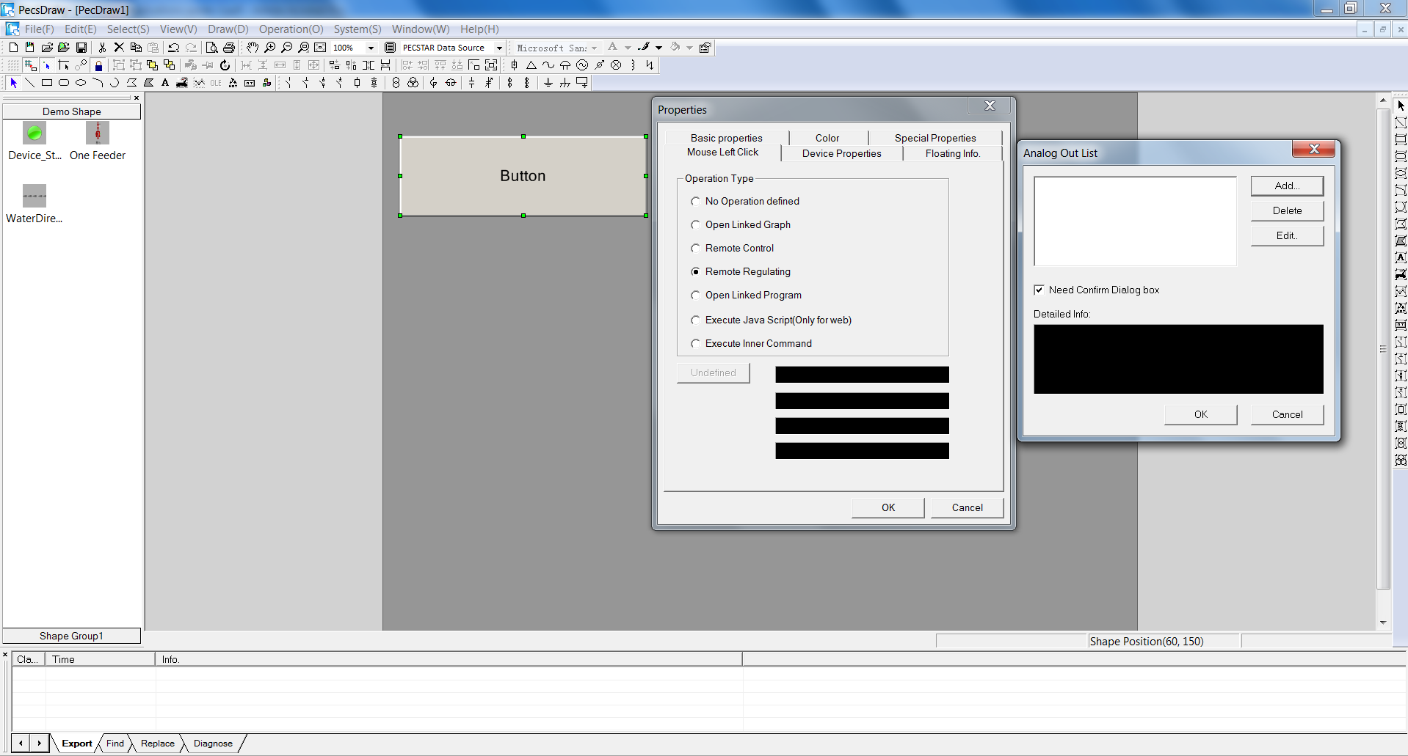
- Click Add…, enter the settings as below:
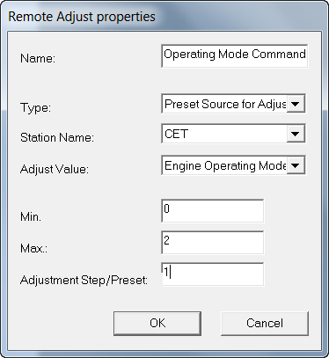
- Save the .drw file.

- Start PecView.
- Navigate to the .drw file. Move the mouse to the Button and click.
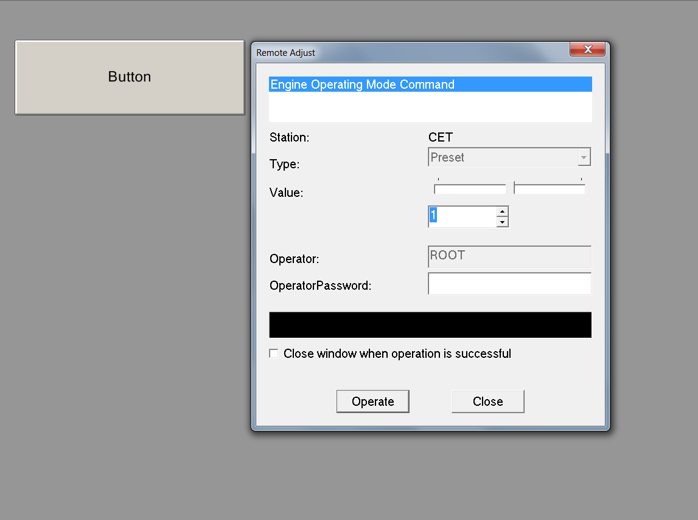
- The Remote Adjust window appears. Click the Up/Down arrow below Value to change it and then Click Operate.
- Click Ok to make sure to send the command and execute.
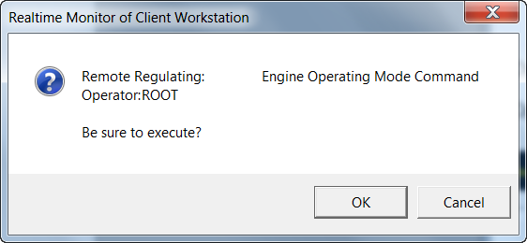
- After the command is executed, a message will appear in the black area.
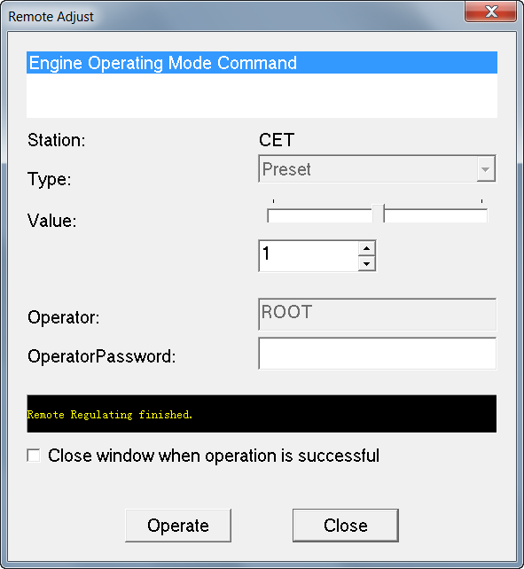
- View the Digital Out Source value from the PecSCADA to check if the command is performed successfully.

